NAME:Rishik JK
REG.NO :192511052

CSA1702-ARTIFICIAL INTELLIGENCE
LAB EXPERIMENT

Experiment 15: Decision Tree Algorithm

Aim
To write a Python program to implement the Decision Tree Algorithm for classification using training data.

Algorithm
- Start the program.
- Create training data containing study hours and results.
- Separate the input values and output label
- Find the best splitting point using Gini Impurity.
- Divide the training data into two groups.
- Create a Decision Tree using the selected split.
- Give new input data to the Decision Tree
- Predict whether the student will Pass or Fail.
- Display the predicted result.
- Stop the program.

OUTPUT:
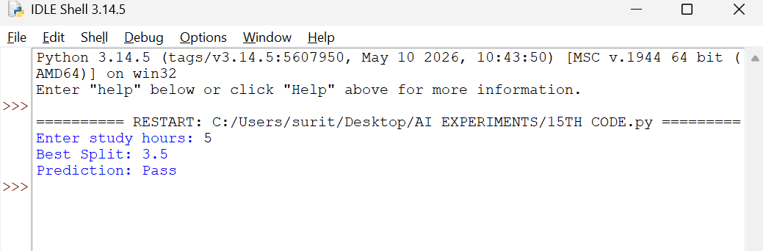
RESULT :
Thus, the Python program to implement the Decision Tree Algorithm using Gini Impurity was successfully executed, and the student's result was predicted as Pass.

